Your proposal must address the following:

Project description and overview

Description of the main subsystems of the design, including the FPGA design details and the features of the MCU you plan to use

An explanation of the new hardware you are using (a new MCU peripheral, new FPGA IP, and a new piece of external hardware), showing that both the FPGA and MCU will perform nontrivial functions appropriate to each

A block diagram indicating chips, connections, and protocols

Calculations of performance-critical parameters (bandwidths, data rates, FFT widths, frame rates, ADC bits, power levels, etc.)

Identification of the riskiest element of the project

A rough schedule and work breakdown (e.g., a Gantt chart) showing how tasks will be divided among team members

A bill of materials / budget — see Purchasing Parts for how to handle parts not available in the stockroom

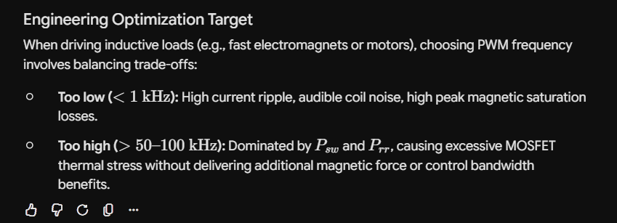

Magnetic Levitation Project Proposal
Stephen Kanti Mahanty and Ben Lertwachara | ENGR 155

Project overview and specifications
Our project will suspend a small permanent magnet with a ballast below an electromagnet and let the user change its height through a webpage. A Hall sensor will measure the magnetic field of the suspension target. We will use this reading to estimate height and adjust the coil current to keep the object in place. We plan to use the STM32L432KC microcontroller (MCU), UPduino FPGA and course ESP8266 Wi-Fi module.
The system will hold the target indefinitely at a maximum gap of 10 mm and while moving with a visible speed at the maximum gap. We will check height with a ruler or camera. The webpage will display height, current and faults. A stop command, overcurrent, E-stop or 50 ms without valid MCU commands will turn off the coil drive.

Two Options for Placement
One hall sensor. We will place one linear Hall sensor in its intended position relative to the electromagnet and record its voltage at known coil currents. To measure the current we will use a shunt resistor and ADC. These measurements will give us a table or fitted curve for estimating our EM’s contribution to our hall effect sensor’s readings.
Two hall sensors. We will add a second Hall sensor at an orientation where the EM field should be opposite to that measured by our first sensor. The difference between these readings should cancel out the contribution from our EM and correspond to the dropoff of our target’s field.

Biggest challenge
Our biggest challenge will be successfully isolating the magnetic field of our target from our sensor readings. We are aware that ferrous materials in the environment could affect these readings so our testing and calibration will be done on wooden or plastic desks. Our one sensor method also depends on current and field readings that are accurately temporally paired. Since we are using PWM to control our EM, we are worried about our sensors picking up those oscillations and then being mismatched due to very slight timing differences. If this ends up being a problem, we could implement moving averages in software for the offending readings. If we are willing to sacrifice EM strength, we can regularly force our current to 0 and take readings at that point. Our two sensor method depends on the symmetry of our emf and the precision of our sensors when placed near strong magnetic fields. We still plan to start with this method since we can leverage the differential mode of our ADC to prevent emf from taking up most of the resolution. It might be too difficult to cancel out the emf entirely, so we might also include current sensing for calibration. If using hall effect sensors becomes really problematic, we can switch to using ultrasonic or optical distance sensing.
We are also worried about the physical dynamics of our system. With just a simple EM providing lift, we are confident that the system will be controllable with a PI controller. However, we want to add permanent magnets to augment the maximum stable suspension gap. This adds an additional force on our target and another equilibrium state to avoid. We think adding a minimum commandable suspension gap, maximum velocity, and a velocity controller will address this, but it’s hard to know for sure. It will also be harder to test since we will have to be careful to protect our hardware from the target flying up. We are also unsure of exactly where to position the permanent magnets.

Two ways to divide the control work
FPGA control: The FPGA will interface with the ADC over SPI to read the differential output across our two analog hall sensors and estimate the target’s field. It will also interface with the MCU over SPI to receive position commands and send debug information. At least a PI controller for position control will be implemented on the FPGA and current and velocity controllers if required. The FPGA will also generate the PWM signal used to control the EM. The MCU will interface with an ESP wifi module over UART to host a website for users to input position commands. It will also interface with the FPGA over SPI to send the position commands and receive debug information.
Peripherals: FPGA will use the DSP blocks to accelerate PI controller calculations and potentially memory blocks to store calibration values. MCU will use DMA for polling of debug information over SPI.
Shared control: The MCU will interface with the hall sensor over SPI. It will also interface with the FPGA over SPI to send desired current commands and receive debug information. Based on the desired current and the hall readings, the MCU will calculate the target’s field and run PI loops for position and velocity. The MCU will also interface with an ESP wifi module over UART to host a website for users to input position commands. The FPGA will interface with the ADC over SPI and run a PI controller for current. It will also interface with the MCU over SPI to receive current commands and send debug information. The FPGA will also generate the PWM signal used to control the EM. Peripherals: FPGA will use the DSP blocks to accelerate PI controller calculations. MCU will use DMA for polling of debug information over SPI.
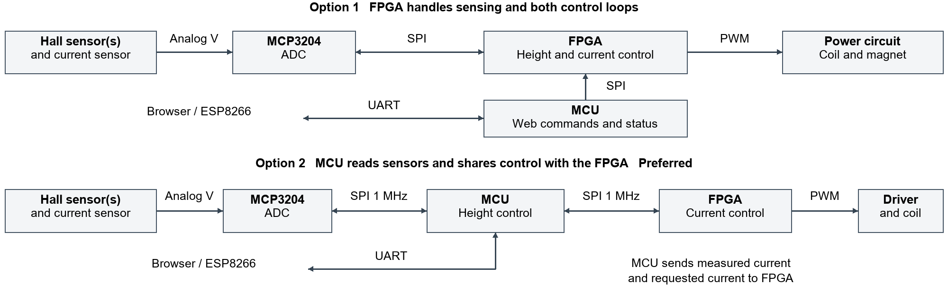
Both designs use one or two Hall sensors plus a current sensor. ADC means analog-to-digital converter; PWM switches coil power on and off. Coil current and magnet position affect the Hall readings, completing the feedback path. Wi-Fi links browser to ESP8266; UART links ESP8266 to MCU. In option 2, ADC and FPGA share the MCU SPI bus with separate chip-selects.

MCU and FPGA design for option 2
The MCU will use SPI1 with separate chip-select pins for the MCP3204 ADC and FPGA. A timer will start sensor readings 5000 times per second; direct memory access (DMA) will help move SPI data. Every fifth reading, the MCU will estimate height and use position and motion feedback to update the requested current. USART1 will communicate with the ESP8266 at 125000 baud. A separate GPIO signal will permit coil operation. Reading an external ADC, calibrating the Hall measurements and running feedback control are the main MCU tasks.
The FPGA will compare measured and requested current 5000 times per second. Its PI controller will use the current error and accumulated error to adjust how long the coil stays on. It will generate 20 kHz PWM and turn off drive after 50 ms without valid commands or when a fault occurs. This adds current feedback and an independent shutdown timer beyond basic PWM. The power circuit will include a MOSFET, gate driver, flyback diode, current shunt and amplifier. A comparator and physical E-stop will disable the driver directly; a catch tray will support the object if it falls.

Performance calculations
At 1 MHz SPI, each 24-clock ADC reading takes 24 µs. With a 1 µs gap, current plus one Hall sensor takes 50 µs; adding the second Hall sensor makes this 75 µs. An 8-byte MCU–FPGA packet takes 64 µs, or about 68 µs with chip-select gaps. The two-sensor case therefore uses 143 µs of each 200 µs sampling period, leaving 57 µs for processing and other work. The packet will carry measured current, requested current, sequence, flags and a checksum. We will measure actual timing before changing and tuning the controller.
The ADC has 4096 levels, so 3.3 V / 4096 = 0.806 mV per count; height resolution still depends on calibration. With a 0.100 Ω shunt and amplifier gain of 20, current resolution is about 0.403 mA per count. At 0.5 A, shunt power is I²R = 25 mW. A 24 MHz FPGA clock divided by 1200 gives 20 kHz PWM.

Bill of materials and budget
Part or planned component | Quantity | Unit cost | Total
NUCLEO-L432KC; UPduino v3.1 | 1 each | Course kit | $0
ESP8266; frame; | 1 each | Stockroom* | $0*
Bench supply; fuse; connectors | 1 set | Stockroom* | $0*
DRV5055A3 or A4 linear Hall sensor | 1 or 2 | $3 | $3 or $6
MCP3204-CI/P ADC | 1 | $6 | $6
INA240A1 current amplifier | 1 | $4 | $4
0.100 Ω 1% shunt, at least 1 W | 1 | $1 | $1
UCC27511 gate driver | 1 | $2 | $2
N-channel MOSFET ≥30 V; flyback diode | 1 each | $2; $1 | $3
IC adapters, resistors and capacitors | 1 set | $4 | $4
Electromagnet; magnet and carrier | 1 each | $8; $2 | $10
Parts subtotal with one or two Hall sensors | — | — | $36 or $39
Shipping allowance; tax allowance | — | $6; $4 | $10
Estimated total with one or two Hall sensors | — | — | $46 or $49
*Stockroom availability is not confirmed. Prices, shipping and tax are planning allowances, not quotes. Final coil, switch and protection part numbers will follow the first hardware tests.

Schedule and work breakdown
Week
1 | Test FPGA to MCU SPI communication and ADC to FPGA communication
2 | Stephen: Setup and test electromagnet and FPGA pwm  Ben: Setup and test hall effect sensor differential reading from FPGA
3 | Develop and test position estimation with running electromagnet, refactor if not working
4 | Ben: Develop and test PI controller  Stephen: Setup lifting hardware (make fixture for permanent magnets, hall sensors, and electromagnet)
5 | Ben: Tune PI controller and implement additional controllers if needed  Stephen: Implement position control website
6 | Final smoke tests and presentation

